**Assembling the Intel® Edison board with the Arduino expansion board**

In this guide, you’ll connect the Intel® Edison module to an Arduino expansion board.

Requirements

* Intel Edison module
* Arduino expansion board
* 2 Micro B to Type A USB cables
* A direct current (DC) power supply. Your power supply should be rated as follows:
  + 7-15V DC
  + At least 1500mA
  + The center/inner pin should be the positive pole of the power supply

**Note:** An external power supply is the preferred way of powering the Intel Edison board. However, you can power your board over USB if you do not have an external power supply.

Assemble your board

1. Place the Intel Edison module within the white outline on your expansion board, lining up the holes on the module with the screws on the expansion board.

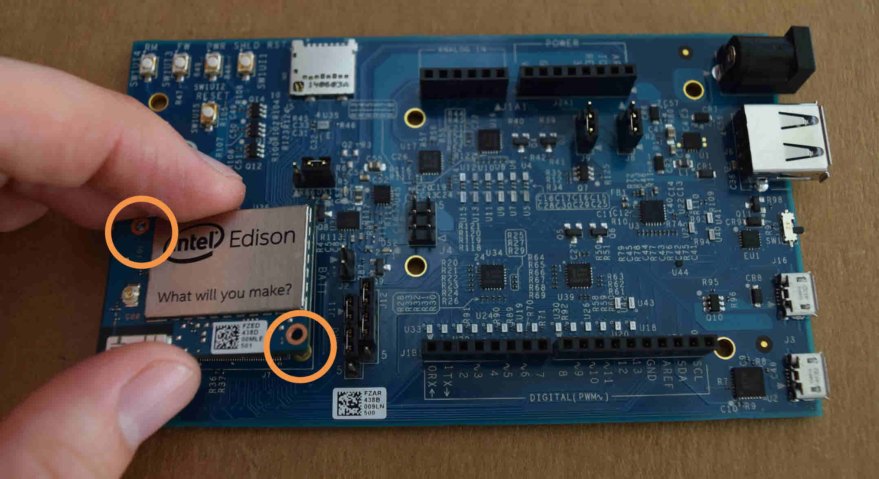

1. Press down on the module just below the words **What will you make?** until you feel a snap. When you turn the attached module and expansion board on their side, both pieces should fit evenly and sit in parallel with each other.

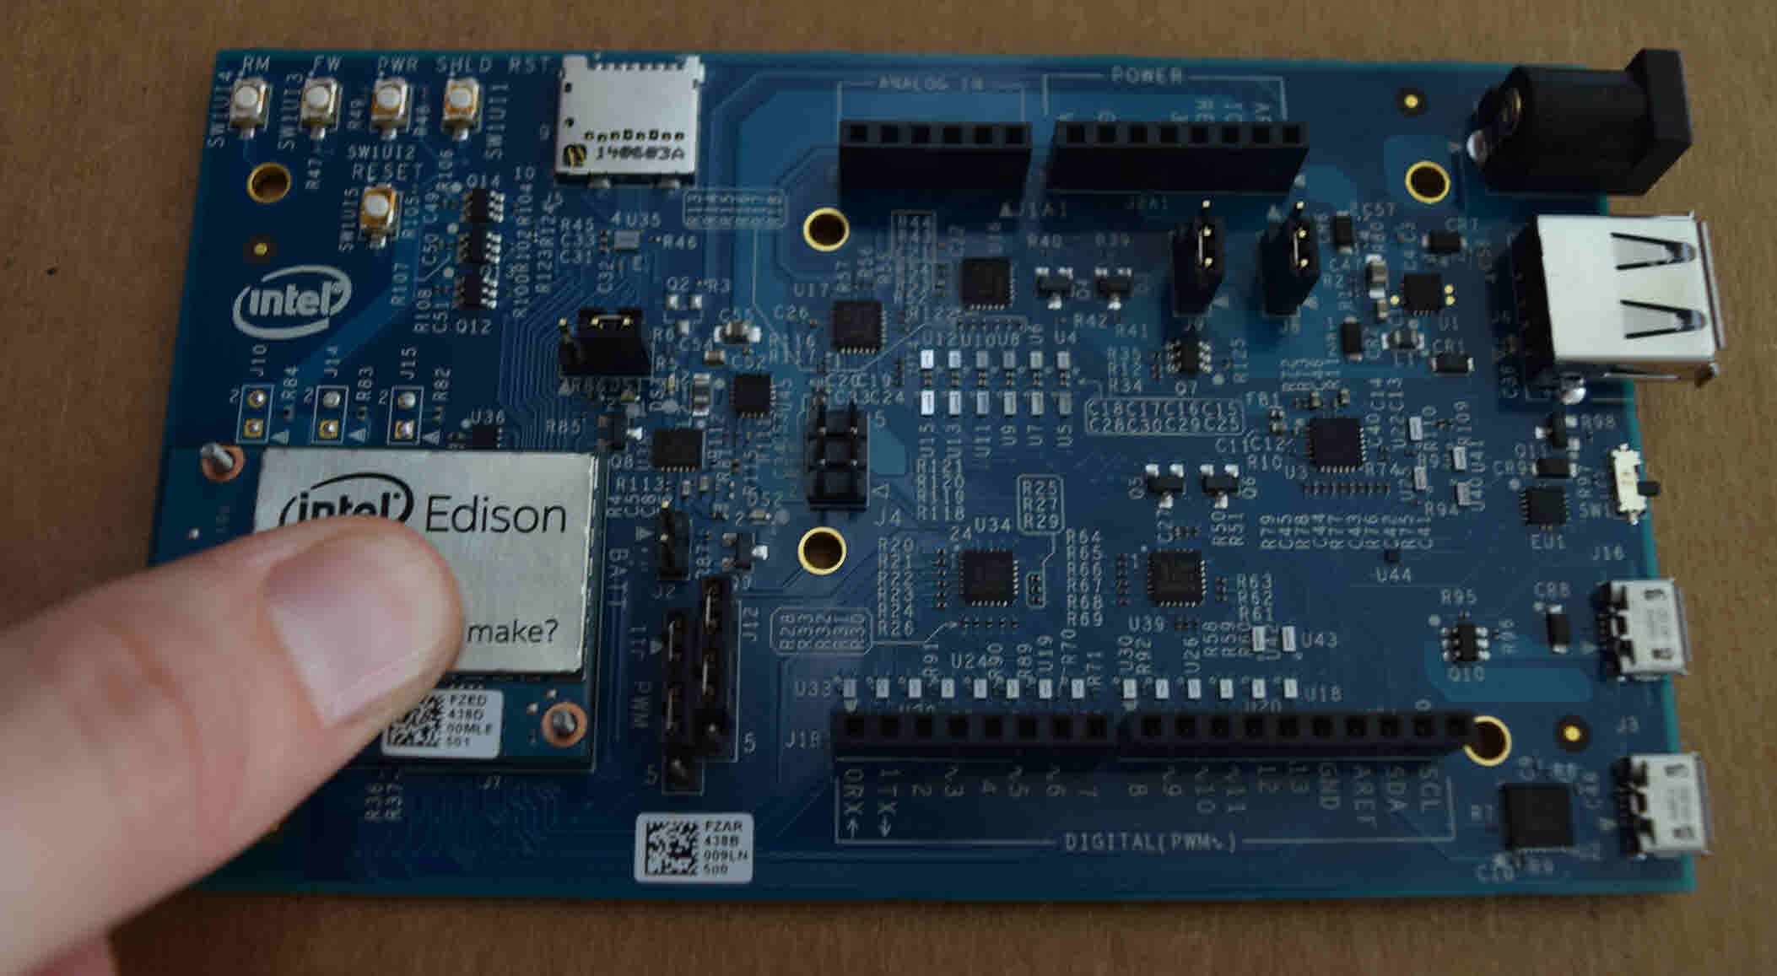

1. Use the two hex nuts (included in the package) to secure the module to the expansion board.

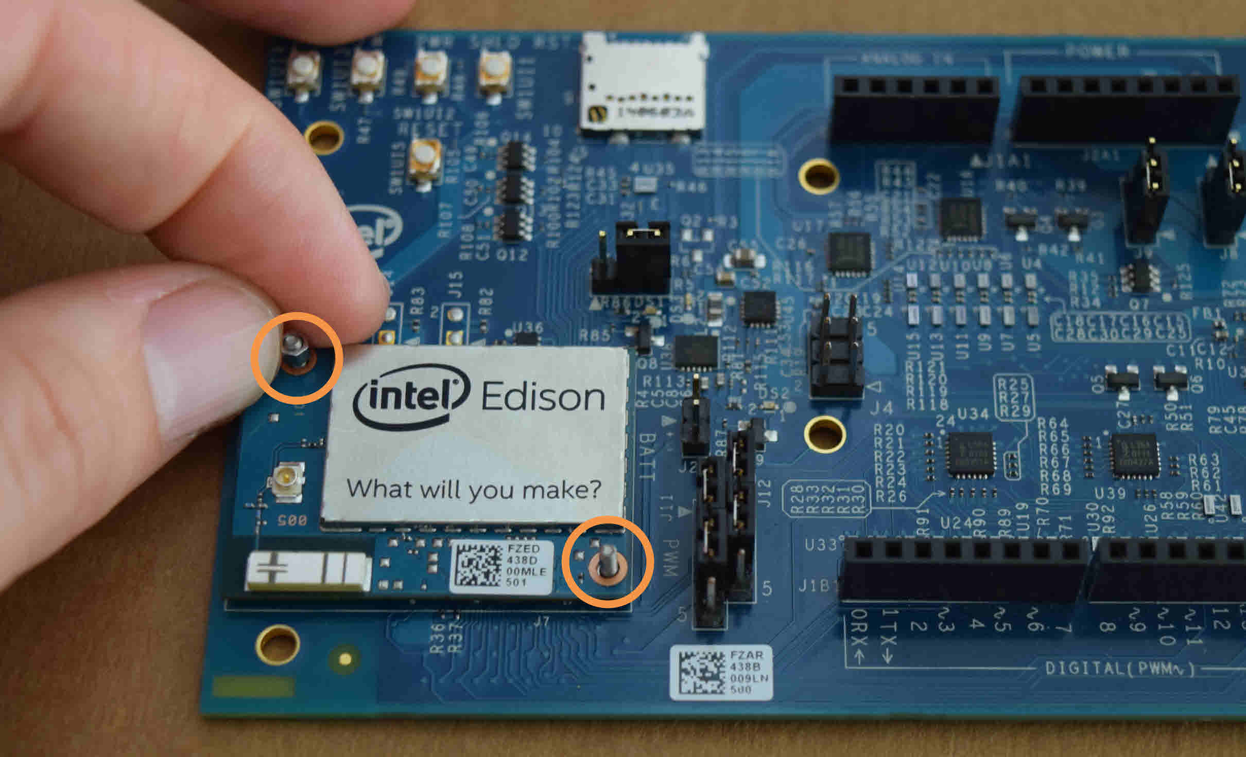

1. Insert a screw in the corner hole and attach the plastic spacer.

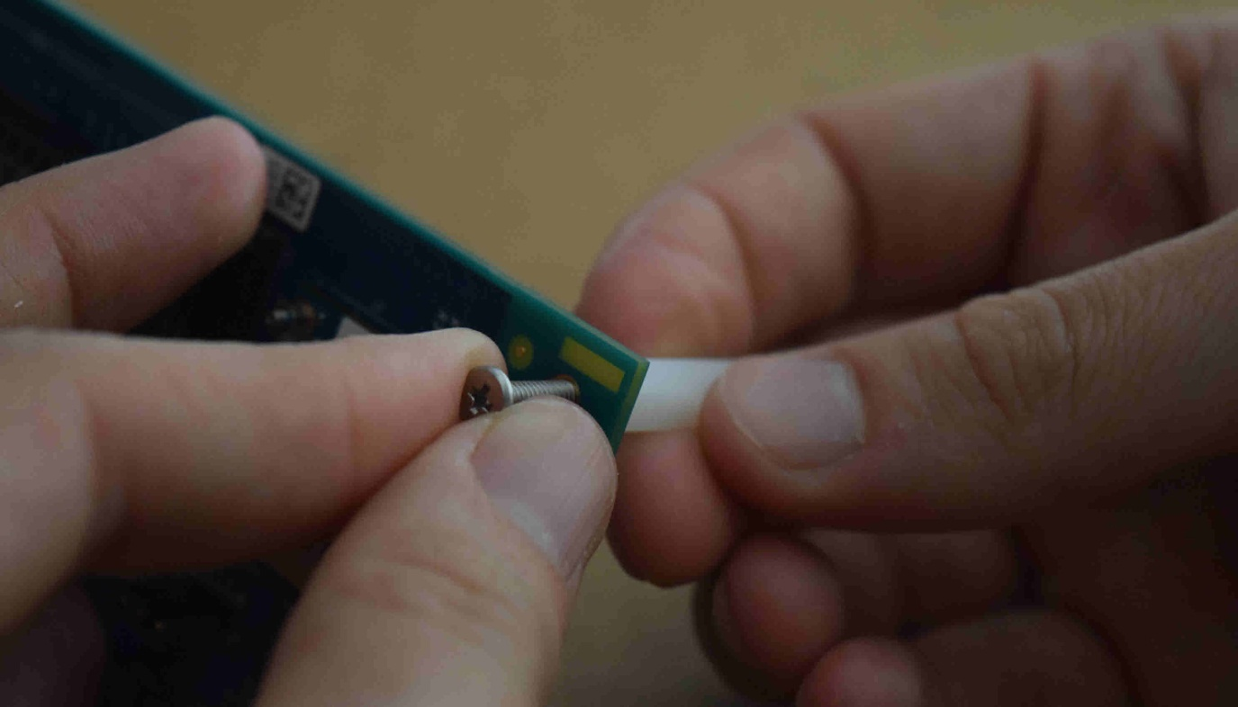

1. Repeat for the other three corner spacers.

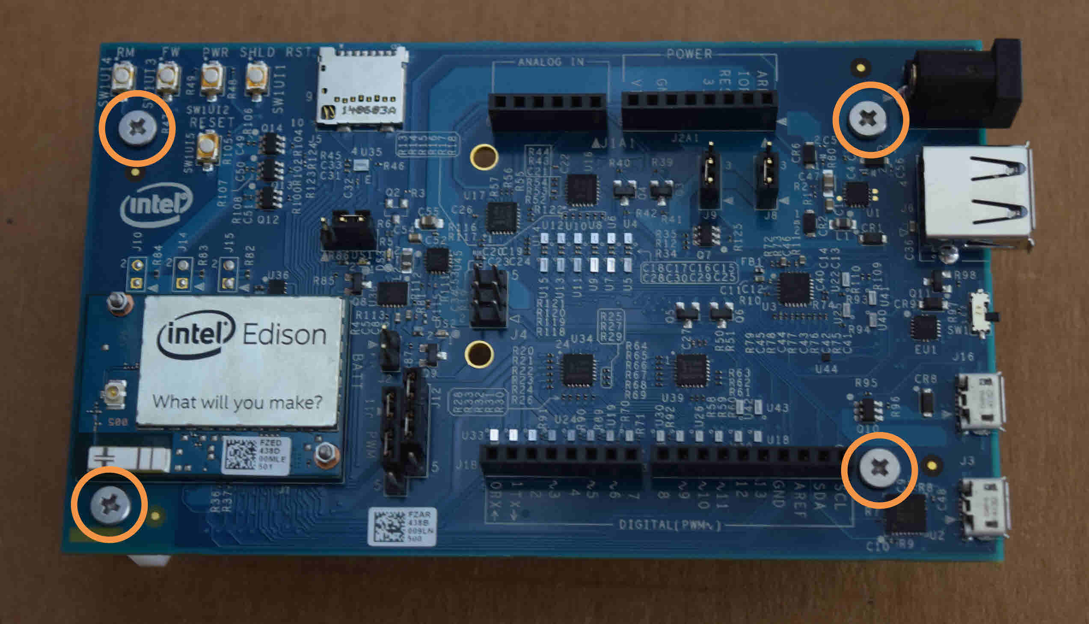

Connect the board to your System/PC

1. Plug in the power supply.  
     
   **Note:** If you do not have a DC power supply, you can still power the board through a USB port. See the [Powering your board over USB](https://software.intel.com/en-us/assembling-intel-edison-board-with-arduino-expansion-board#poweroverusb) section for details.

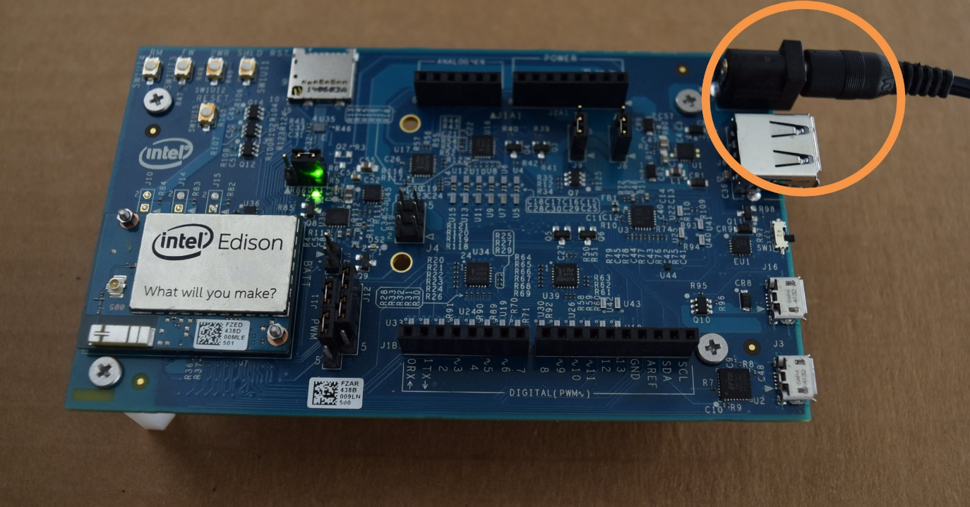

1. A green LED should light up on the expansion board. If it doesn't, check your connection.

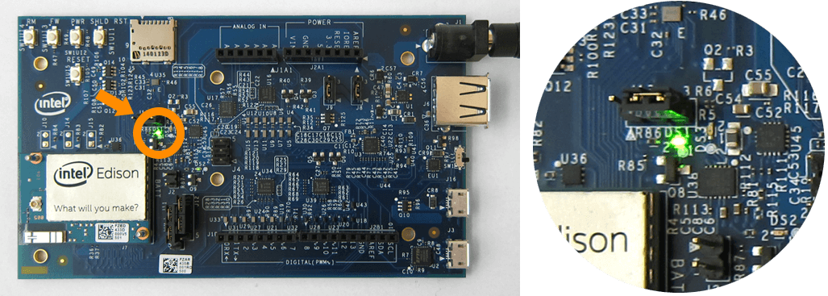

1. Find the microswitch in between the USB ports on the expansion board. Switch the microswitch down towards the micro-USB ports, if it isn't already.

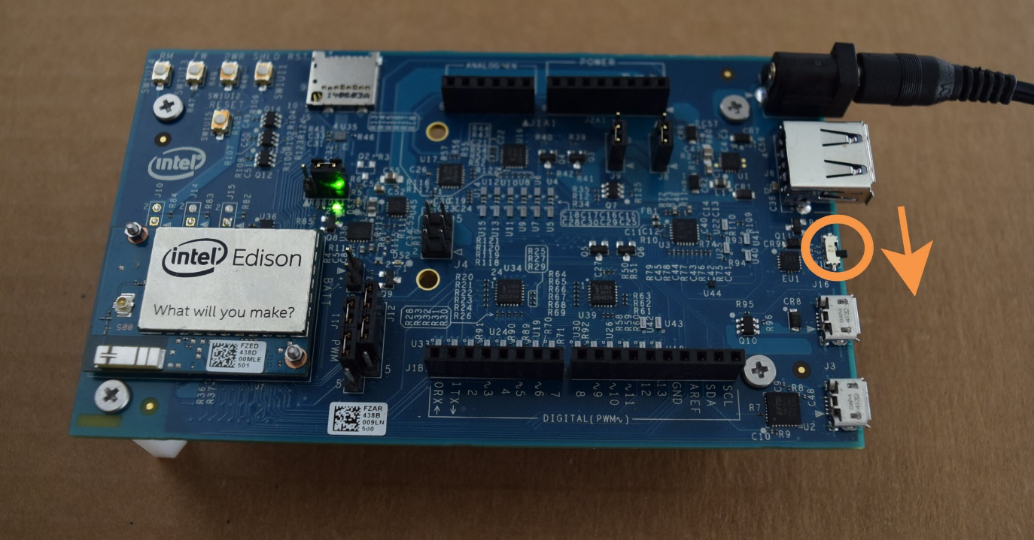

1. Plug in one of the micro-USB cables to the ***middle*** USB connector on the expansion board.

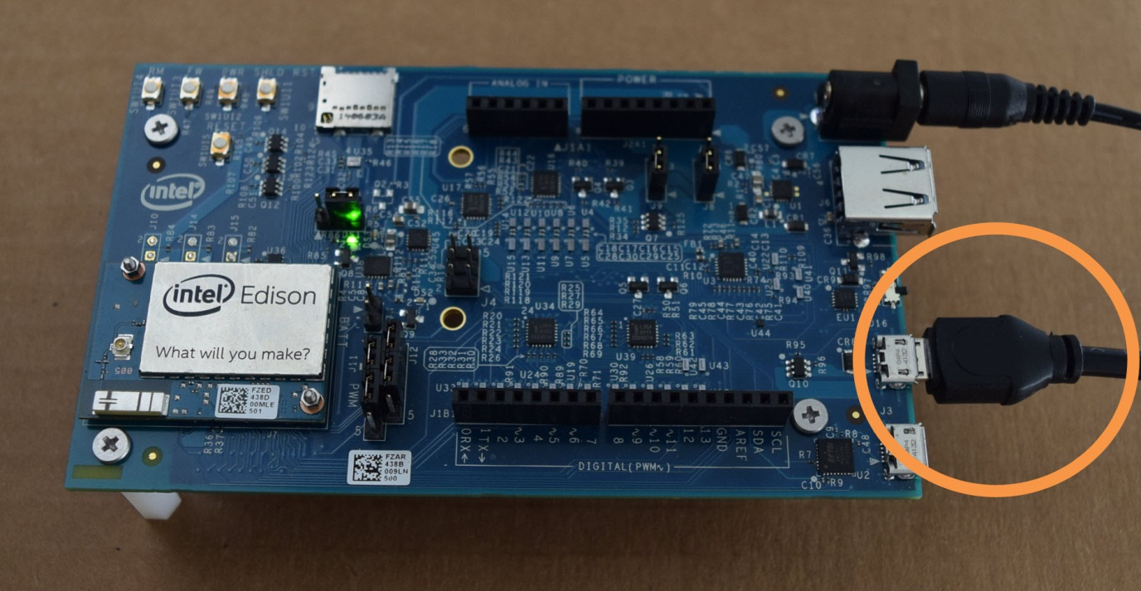

1. Plug in the other end of the USB cable to your computer.

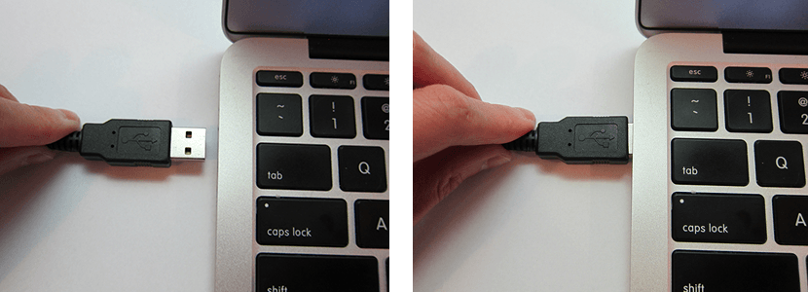

## How do you know when the board is ready?

You will know that your board is fully initialized when your computer mounts a new drive (much like inserting a SD card into your computer).  If you do not see a new drive, or the LED light (DS1 on the Arduino expansion board) is occasionally turning on and off, check the connection of your power supply.

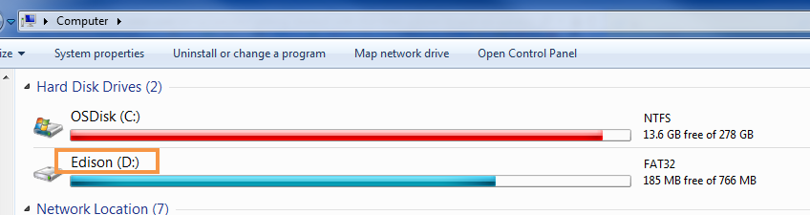

1. Plug in your second USB cable to the ***edge*** USB connector on the board.

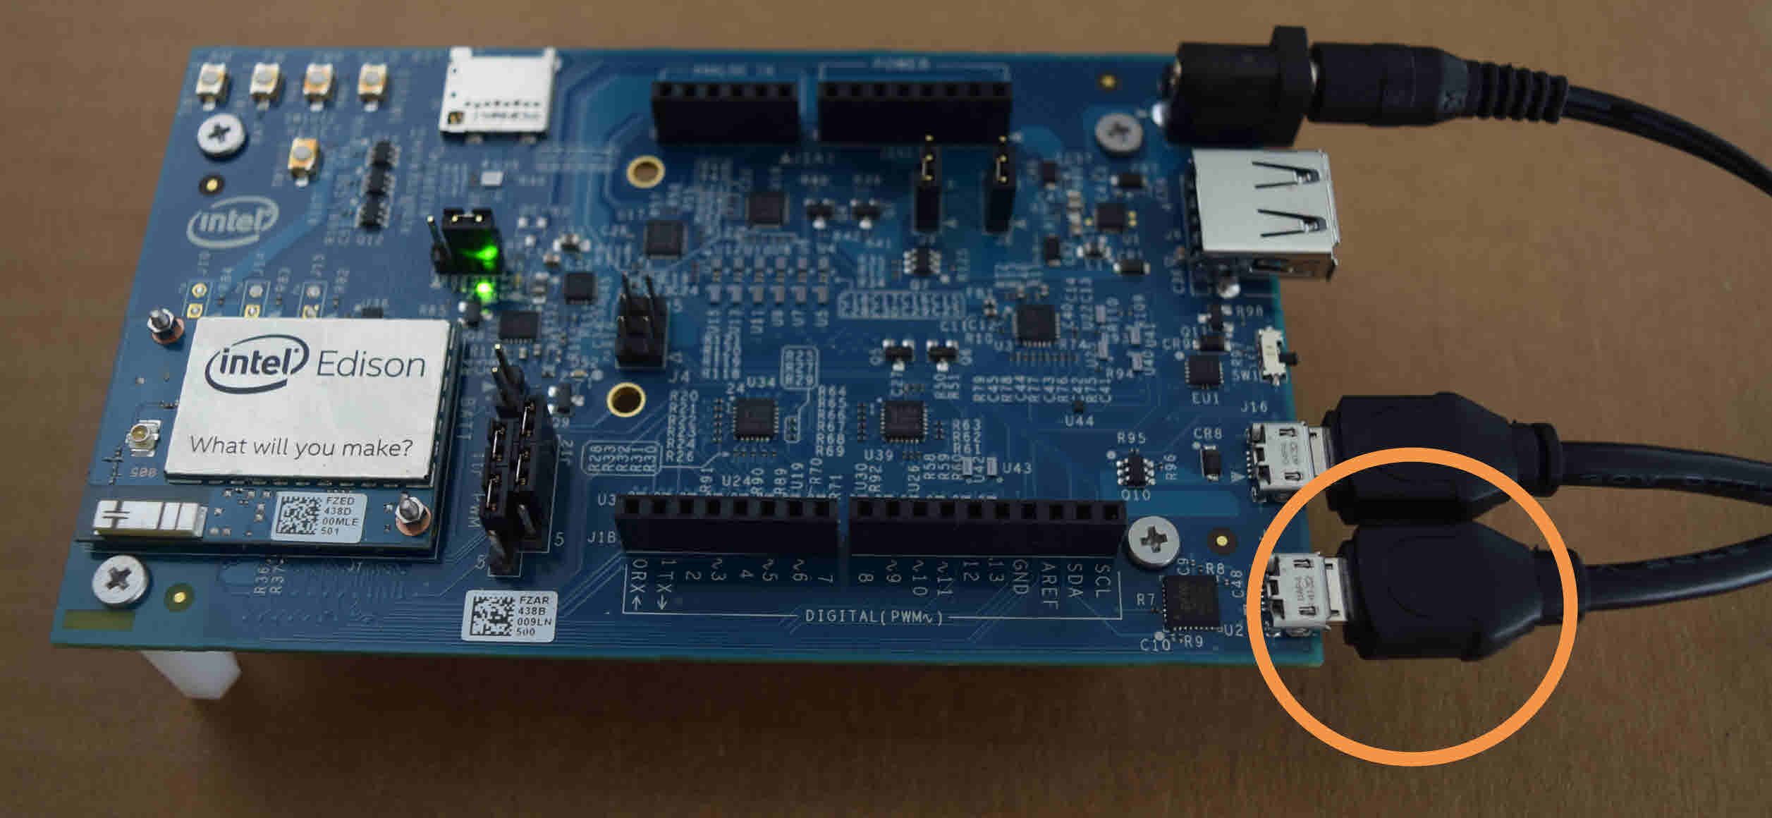

1. Plug the other end of the USB cable in to your computer.



Now that you have assembled your Intel Edison board, continue with the setup process by installing required drivers.

## Install USB drivers

1. Download the [Windows 64 bit installer](http://downloadmirror.intel.com/24738/eng/iotdk_win_installer.exe) and run it.
2. Follow prompts, will look similar to following steps.

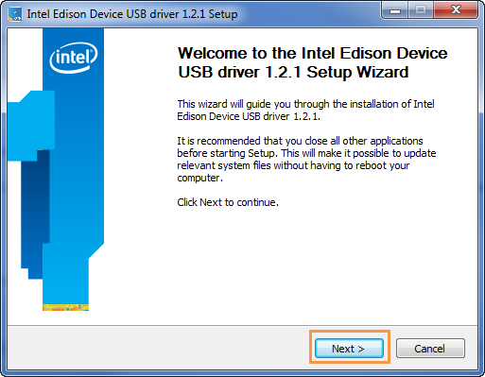

1. Click **I Agree**.

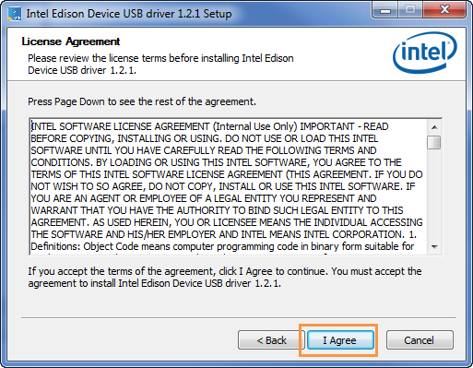

1. Click **Next**.

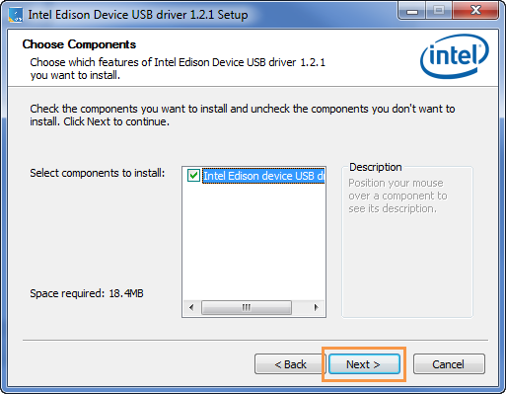

1. Click **Install**.

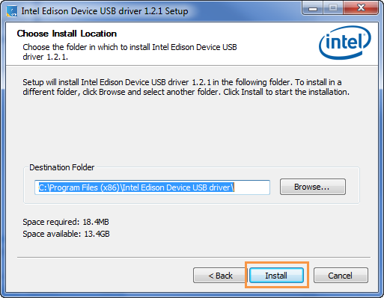

1. Click **O**K.

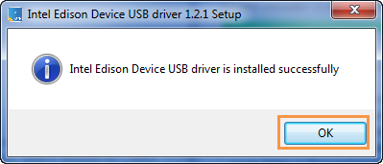

1. Click **Finish**.

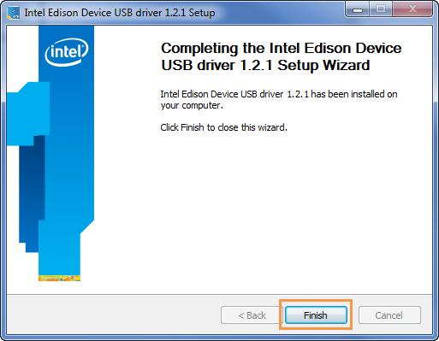

1. Unplug the micro USB cable from the middle micro USB port, then plug it back in.

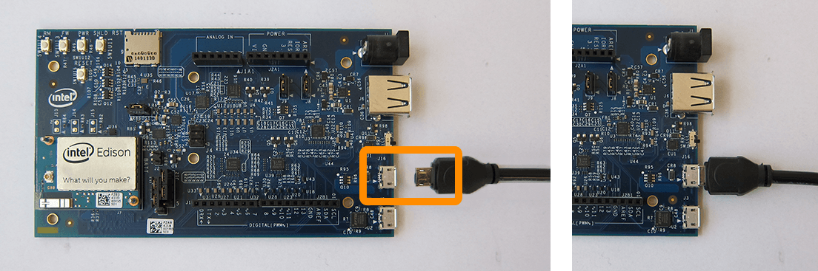

## Install FTDI drivers

1. Download the Windows setup executable from the following location: <http://www.ftdichip.com/Drivers/D2XX.htm>
2. Right-click the file and select **Run as administrator**.

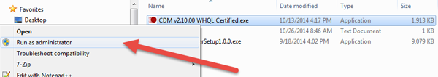

1. Follow the on-screen instructions to install the drivers, then reboot your system.
2. Navigate to the Device Manager and check for an entry called **USB Serial Port** (not Intel Edison Virtual Com Port). Make a note of the COM#, as highlighted below; you'll need this later.

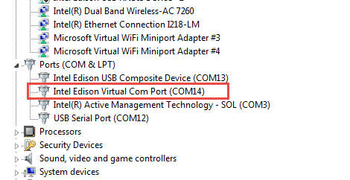

## Install PuTTY (for Serial connection)

1. Check for a **"USB Serial Port"**(not "Intel Edison Virtual Com Port") in the Device Manager.

[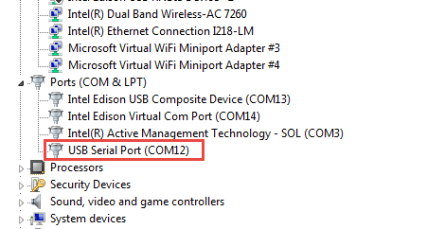](https://software.intel.com/sites/default/files/managed/b3/0c/Edison_Windows_usbserialport_cropped_3-4-15_0.png)

1. Download the PuTTY terminal emulator: [http://the.earth.li/~sgtatham/putty/latest/x86/putty.exe.](http://the.earth.li/~sgtatham/putty/latest/x86/putty.exe)
2. Double-click the putty.exe file you downloaded to run it. Save this in a known location for future use.
3. Configure the PuTTY menu as follows, like in next diagram
   1. Select **Serial** under Connection type.
   2. Enter your **COM#** (the number you found above)
   3. Enter **115200** for the Speed

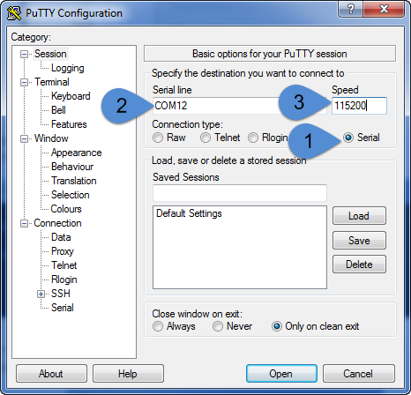

When you see a blank screen, press the Enter key twice, you should see a login screen like below  
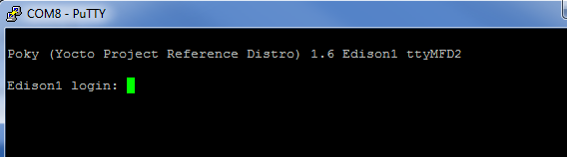

Flashing the Firmware

This guide contains steps to update (flash) the firmware on your Intel® Edison board. The firmware is your board’s operating system, and also allows for use of Wi-Fi*, Bluetooth*, analog and digital controls, and other functions.  It’s important to keep your firmware up-to-date to ensure the best stability and performance for your board.

* Once you have connected your board, you should see a drive called **Edison** show up in Windows Explorer. Remember this drive letter (in this example it is D:) for later use.

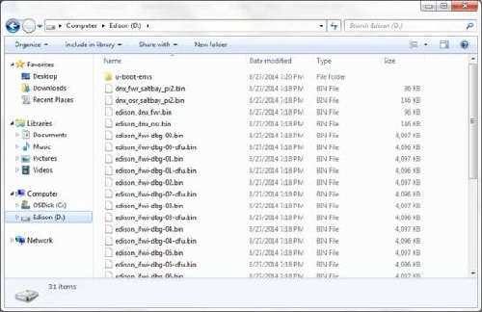

## Remove old images

1. Open a new command window by clicking **Start**. Type cmd and press Enter.

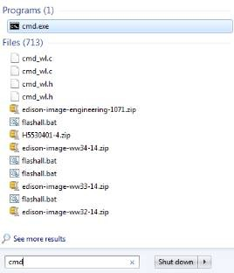

1. Type the drive letter of Edison that you noted earlier and press **Enter**.

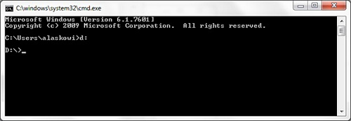

1. Enter the command:   
     
   del *  
     
   At the prompt, type y and press **Enter**.

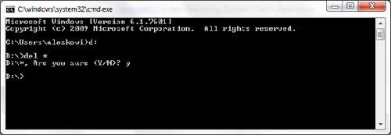

1. All files should now be removed. To confirm, type dir and press Enter to view files on the drive.

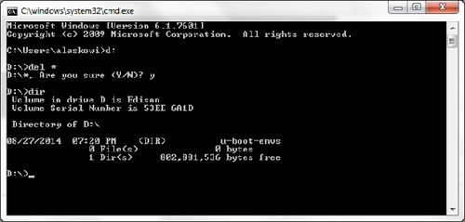

## Download the latest image

1. Download the **Yocto complete image** from the following location: http://downloadmirror.intel.com/24910/eng/edison-image-ww18-15.zip
2. Unzip the contents and move these files into the Edison drive. If necessary, overwrite any existing files.

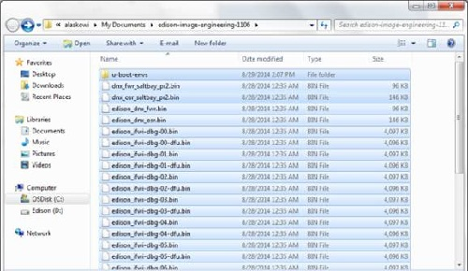

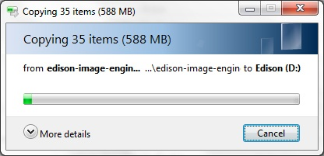

1. Verify that your Edison drive contains the new files, as shown below:

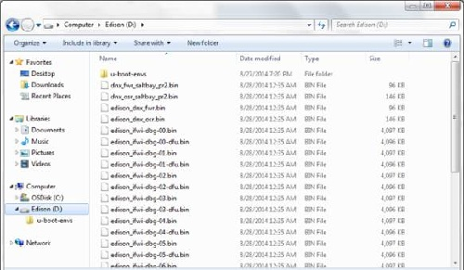

## **Flashing your board**

1. Open **Device Manager** by clicking **Start** and typing Device Manager.

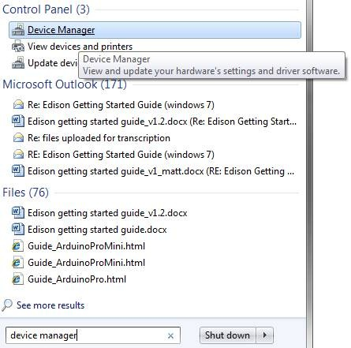

1. Scroll down to **Ports (COM & LPT)** and take note of the COM number listed under **USB Serial Port (COM#)**. In this example, it is COM11.

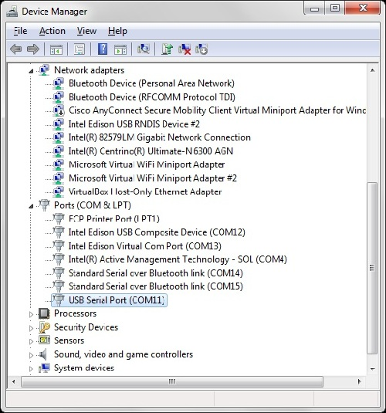

1. Open the PuTTY.exe application that you previously downloaded, then do the following:
   1. Under Connection type, select **Serial**.
   2. In the **Serial line** field, enter the COM# for your board, such as COM12.
   3. In the **Speed** field, type 115200.



1. Click **Open**.
2. A blank screen is displayed. Press **Enter** two times.

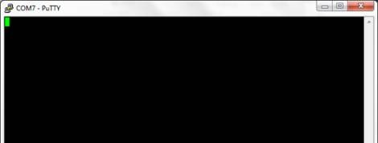

1. Type root and press **Enter**. If you already defined a user name and password for your board, enter the appropriate credentials.

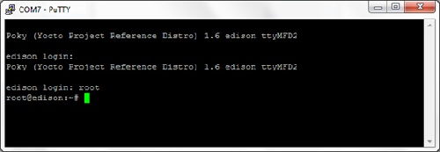

1. Enter the command:  
     
   reboot ota  
     
   **Warning:** This will erase everything on your board, including configuration settings.
2. Your board reboots and begins the flashing process with the latest image. When the flashing process is finished, you should see this screen:

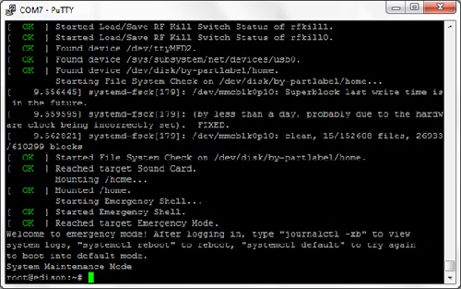

## Configure your user name and password

Because you have just flashed the image on your board, any previous configuration settings you have configured, such as your user name, password, and Wi-Fi* network options, need to be configured again.

1. To assign your board a name, enter the command:  
     
   configure_edison --name
2. Create a login password for your board by entering the command:  
     
   configure_edison –password

# Connecting to a network

This section contains steps to set up network access to your Intel® Edison Board and obtain an IP address. See the appropriate link below:

## Set up Wi-Fi

1. Establish a serial communication session with your board.
2. To configure your Wi-Fi, enter the command:  
     
   configure_edison --wifi
3. When asked if you want to set up Wi-Fi, type Y and press **Enter**.
4. Your board will scan for Wi-­Fi networks for 10 seconds. When it is finished, a list of available networks will be displayed. If you don’t see any networks, enter 0 to rescan.  
     
   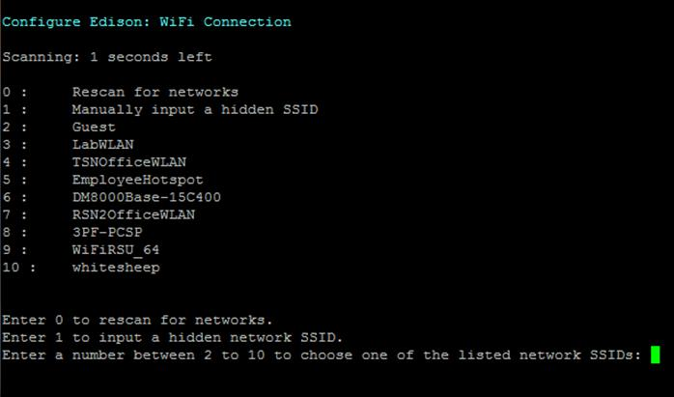
5. Choose the network you would like to connect to, type the corresponding number from the list, and press **Enter**. To confirm your entry, type Y and press **Enter**. In this example, to connect to the **kafka** network, enter 16.  
     
   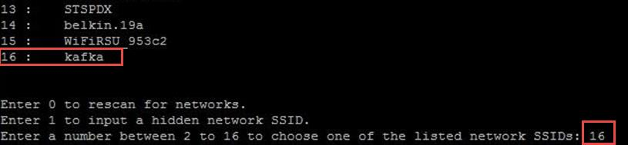
6. If your network requires a password or other information, enter the appropriate network credentials.
7. The board will attempt to make a connection to the network. When you see a **Done** message, your board is connected to a Wi-Fi network.  
     
   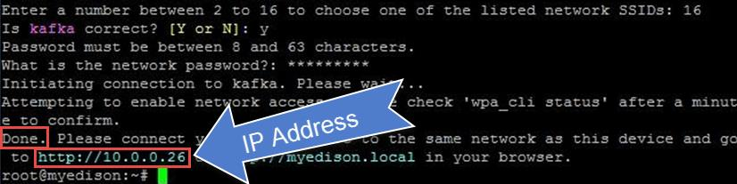
8. Note the IP Address, as shown in the image above. This is your board’s IP Address. Alternately, enter the command:  
     
   ifconfig  
     
   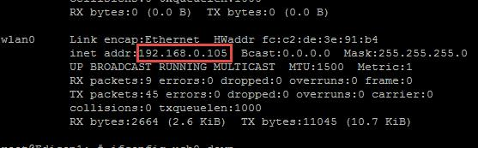  
     
   Make note of your **wlan0** IP address, as shown above.
9. To verify connectivity, you may want to ping your board from another computer on the same network using the IP Address obtained above. Alternately, you can try accessing your board by typing in your IP Address into a browser of another computer on the same network.

If you are having problems connecting, try running the following commands in a serial communication session with your board:

ifconfig usb0 down

ifconfig wlan0 down

ifconfig wlan0 up

Installing Arduino IDE

**.Install USB Driver**, Arduino IDE.

a. If you haven't already, install 7zip, a free archive utility that can be downloaded at: [www.7zip.org](http://www.7zip.org/). See figure below, download non Beta version and appropriate version for your PC.

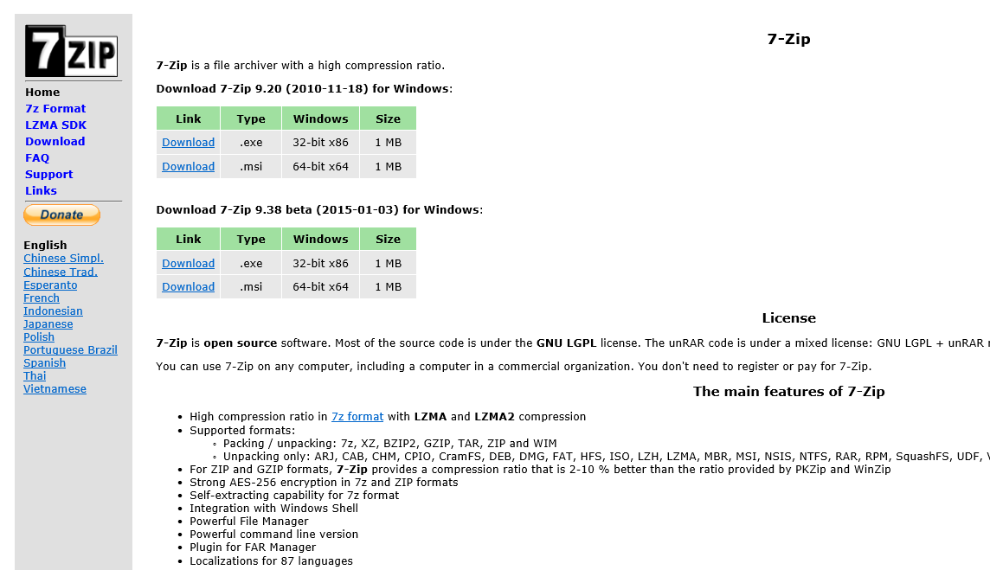

Select Run, and accept prompts, following instructions.

b. Select the [Arduino Windows link](http://downloadmirror.intel.com/24783/eng/IntelArduino-1.6.0-Windows.7z) below to begin install. When asked to “Open” or “Save as”, select “Save as” and save in a known location. <http://downloadmirror.intel.com/24783/eng/IntelArduino-1.6.0-Windows.7z>

c. Navigate to the folder where you downloaded the Arduino IDE .zip file.

d. Right-click on the .zip file, point to **7-zip**, and select **Extract here-…"**. As per below figure

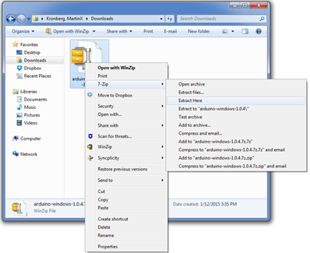

b. Unzip the file to the top directory of your computer (C:/) as shown in Figure 3. You can rename the folder to something descriptive; however, make sure there are no spaces in it.

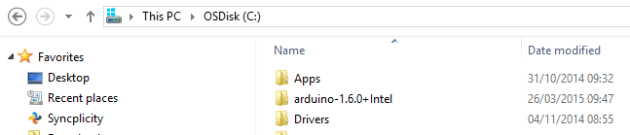

c. Open Arduino.exe, by double-clicking. Note: if you get a message asking if you want to visit the Arduino download page to update, select ***"No"***

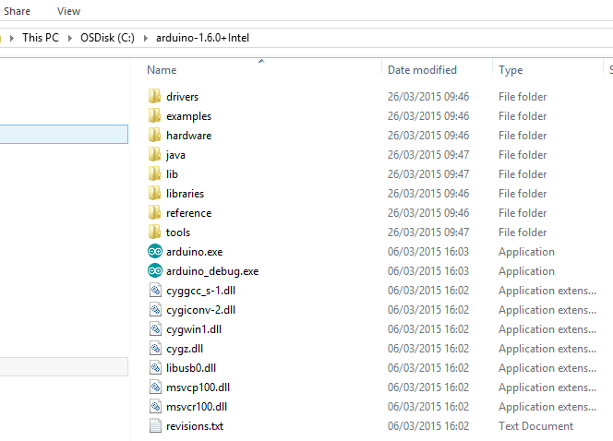

d. Using Arduino IDE, go to the Tools pull-down menu at the top, select Board, and make sure “Intel Edison" is selected.

**Running the Blink Test**

1. Double-click on **arduino.exe** in the folder you extracted it to.

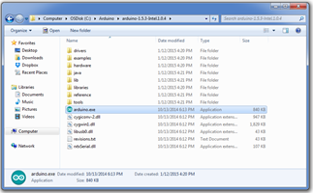

1. Open the LED blink example sketch by choosing **File > Examples > 1.Basics > Blink**.

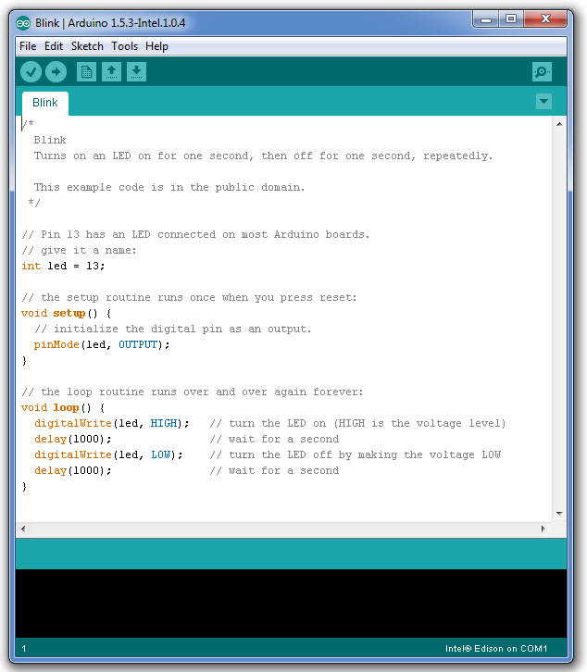

1. Choose **Tools > Board**, then select your board.

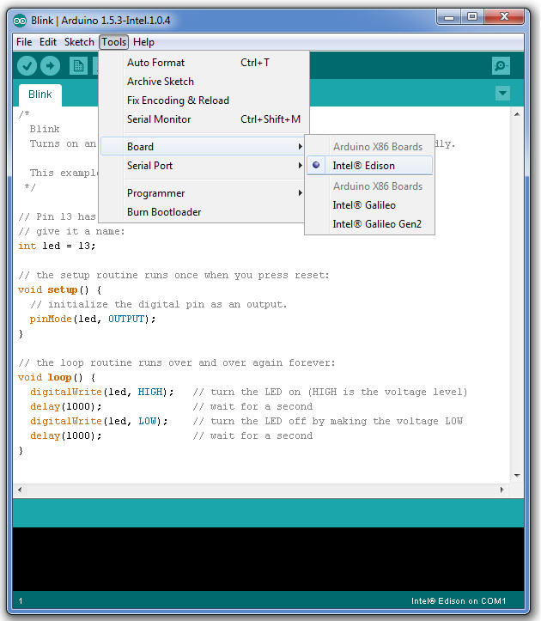

1. Select the serial device of the board from the **Tools > Serial Port** menu. See the instructions below for your specific OS.

### Finding your port on a system with Windows*

1. Find the port for your board, which is likely to be **COM3** or higher and is called **Intel Edison Virtual Com Port** in the Device Manager. It is NOT **USB Serial Port**. **COM1** and **COM2** are usually reserved for hardware serial ports.  Select your COM port.  
     
     
     
   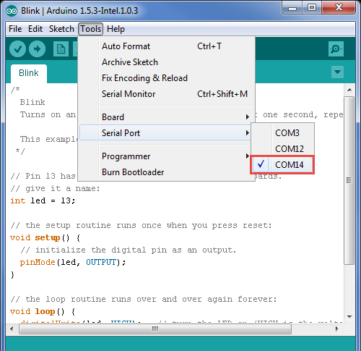
2. Now the bottom right should match the COM port number of the **Intel Edison Virtual Com Port (COM#)** from the Device Manager.  
     
   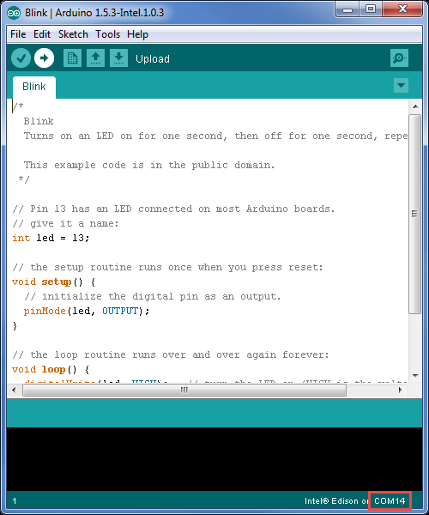

## Uploading the sketch to your board

1. Click the **Upload** icon in the upper left to load and run the sketch on your board.

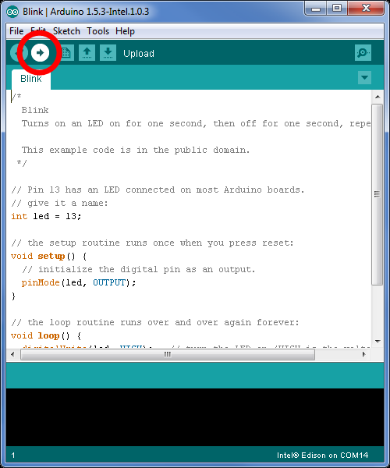

1. You should see **Done Uploading** and **Transfer complete** messages when your sketch has uploaded.

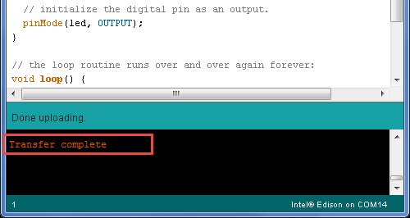

1. The DS2 LED on your board should now blink on or off every second.

